**jMonkey Game Assignment: WallBuster**

**Student**: Patrick Walsh

**School**: University of Maryland Global Campus

**Course**: CMSC 325 6380

**Date**: 10/4/2021

**Professor**: Dr. Michael Elms

**WallBuster: Game Description**

The WallBuster game consists of a platform that has multiple wall objects located on top of it. When the game is launched, the player is facing toward the walls with a crosshair target so that they can see where their weapon is aiming. When the player clicks the left mouse button, a projectile is fired. The goal is to shoot and demolish the walls with the projectiles. The game keeps track of how many shots have been fired.

The inspiration for the game came as I was completing the Java Monkey Engine (jME) tutorials on audio, effects, and physics. I wanted to create a simple game that had the look and feel of a shooter game complete with projectiles that operated on basic physics and objects that would be destroyed upon collision with a projectile. I also added music and gun shot sound effects to make the game more engaging.

**WallBuster: Gameplay**

When the scene is launched, the user sees the platform, 3 walls attached to the platform, the crosshairs of their weapon, and text above the walls indicating the number of shots fired and instructions on how to fire the weapon. See screen shot below:

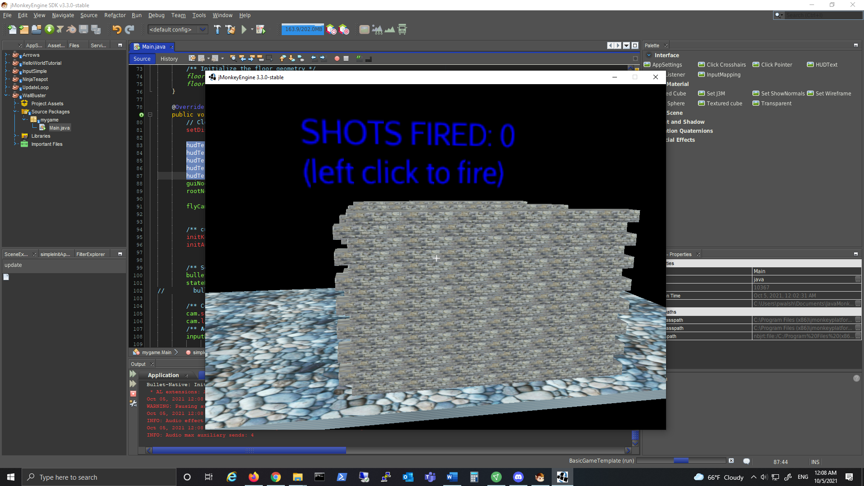

When the user clicks the left mouse button, a projectile is quickly fired toward wherever the crosshairs are pointed. Upon contact with the wall, the projectile causes damage. Both the projectiles and the walls follow realistic physics of gravity and momentum. See screen shots below:

*Projectile being fired.*

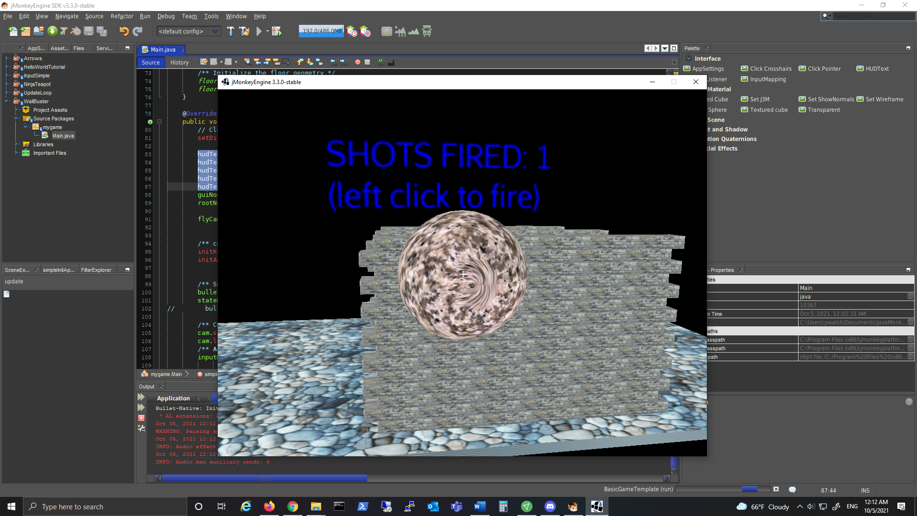

*Projectile striking wall and causing damage.*

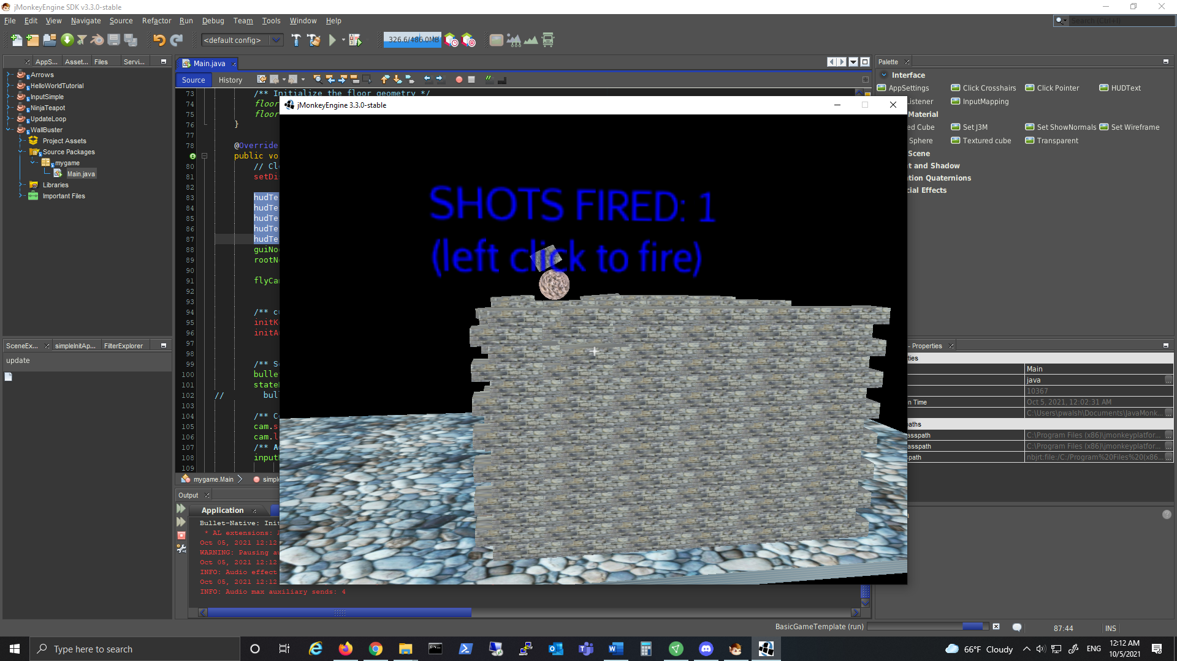

*After 5 shots, the walls begin to crumble.*

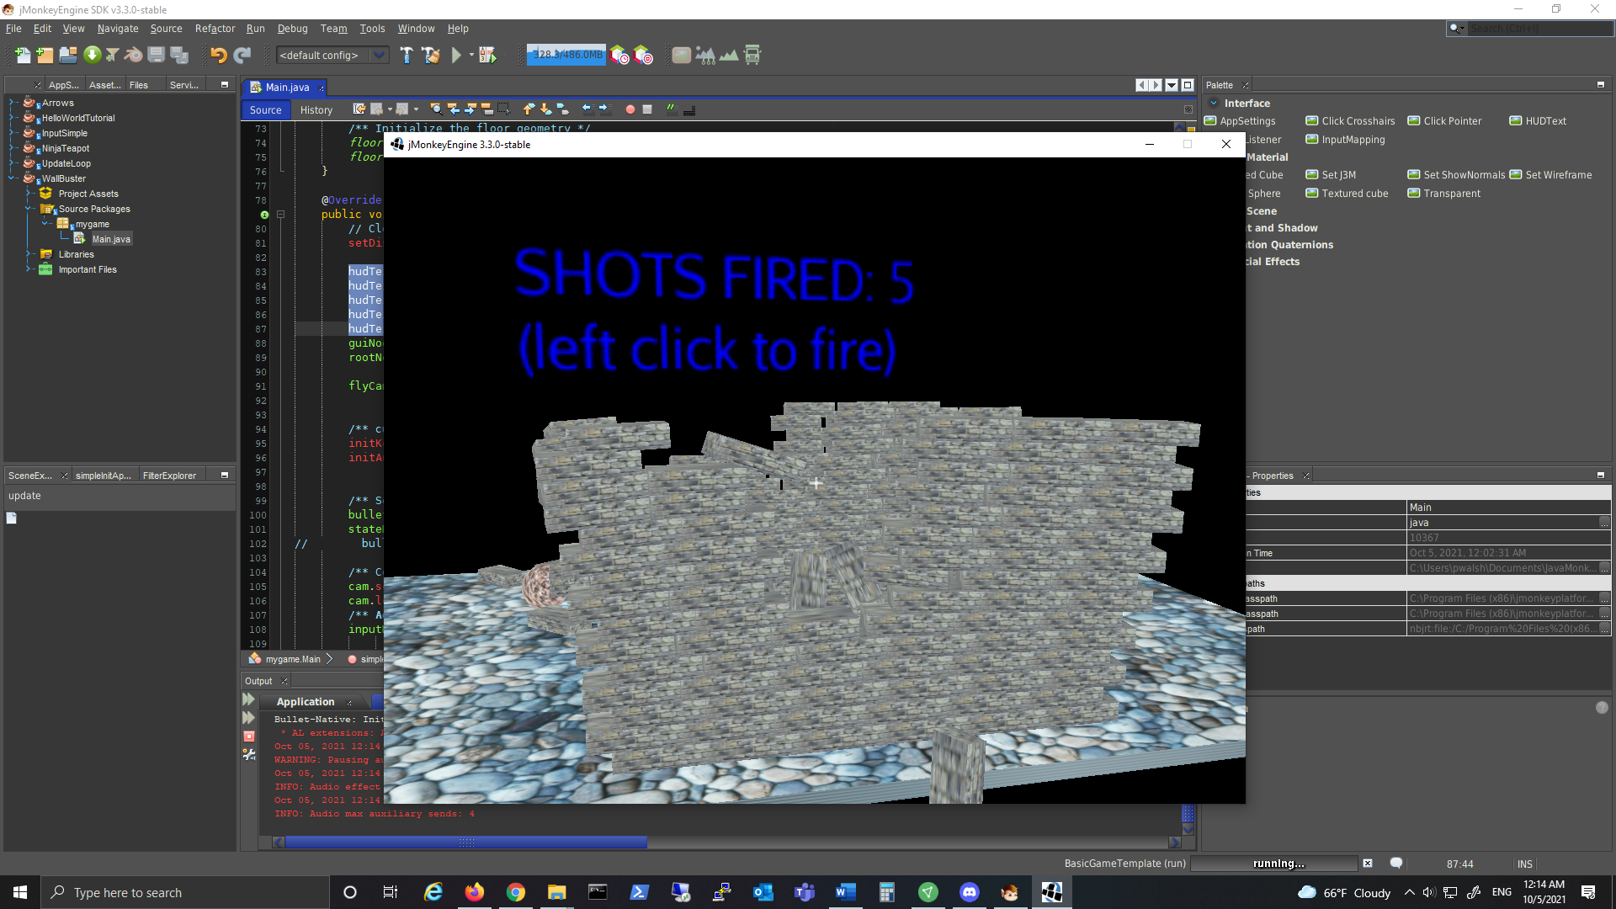

*Several more shots in rapid succession bring the walls down.*

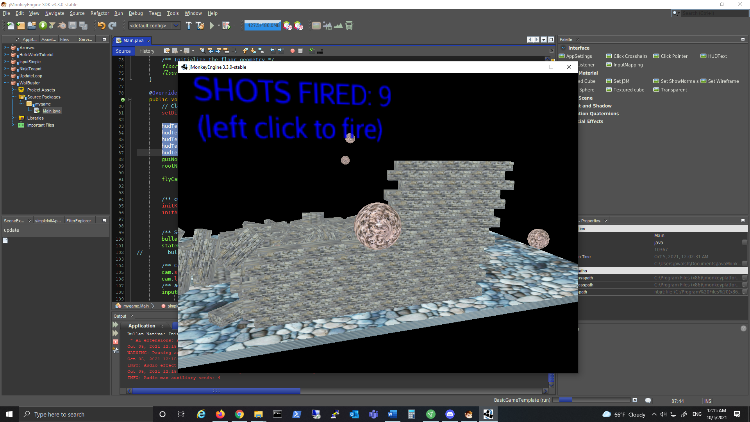

**Coding Sources used:**

<https://wiki.jmonkeyengine.org/docs/3.3/tutorials/beginner/hello_audio.html>

<https://wiki.jmonkeyengine.org/docs/3.3/tutorials/beginner/hello_effects.html>

<https://wiki.jmonkeyengine.org/docs/3.3/tutorials/beginner/hello_physics.html>

<https://wiki.jmonkeyengine.org/docs/3.3/core/ui/hud.html>